AS NZS 3580.9.7-2009
PREFACE

This Standard was prepared by the Joint Standards Australia/Standards New Zealand Committee EV-007, Methods for Examination of Air as an Australian/New Zealand Standard to supersede AS 3580.9.7–1990, Methods for sampling and analysis of ambient air. Method 9.7: Determination of suspended particulate matter-PM, dichotomous sampler-Gravimetric method.

The objective of this Standard is to provide regulatory and testing bodies with a standard method for determining suspended particulate matter with equivalent aerodynamic diameters of less than 10 um and 2.5 um, utilizing a dichotomous sampler and size selective inlet.

The procedure described in this Standard involves batch sampling and the gravimetric determination of coarse PM, PMs and PM...

The term 'normative' has been used in this Standard to define the application of the appendix to which it applies. A normative appendix is an integral part of a Standard.

FOREWORD

Suspended particulate matter measured by this method includes particles with equivalent aerodynamic diameters (EAD) less than 10 um and 2.5 um, as passed by a size selective inlet and virtual impactor (PM, and PMs).
Particles with EAD of 10 um and less are classified as respirable and hence may affect health. Particles larger than 10 um generally have nuisance and aesthetic impacts only. PM emission sources include industrial processes, fuel combustion, burning of vegetation, incineration and natural causes such as wind blown dust and salt laden air,
PM has been statistically associated with certain human health end points, including daily mortality, hospital admissions and exacerbation of asthma PM emission sources include industrial processes, fuel combustion, burning of vegetation, incineration and natural causes such as wind blown dust and salt laden air, Combustion processes tend to contribute more PM than non-combustion sources. Important anthropogenic sources include domestic wood heaters and motor vehicles (especially diesel fuelled vehicles).
METHOD
This Standard sets out a gravimetric procedure for the concurrent determination of the PM10 and PM s fractions of suspended particulate matter in ambient air collected in a dichotomous sampler. The method provides a measure of the mean concentration of PM 0 over the sampling period of the two size fractions, viz. the fine fraction (less than approximately 2.5 um) and the coarse fraction (2.5 pm to 10 um). A procedure for assessing the performance of dichotomous samplers so that they comply with the sampling requirements of this method, is described in Appendix A.

NOTE: Sampling is normally of 24 h duration to average out diurnal variations. Provided that the mass of the filter is determined under carefully controlled laboratory conditions, mean concentrations of 5 ug m (1.67 L/min sample flow rate) or I ug/m (15 L/min sample flow rate) and greater may be determined, based on a 24 h sampling period.
REFERENCED DOCUMENTS

The following documents are referred to in this Standard:
AS
2162 Verification and use of volumetric apparatus
2162.1 Part 1: General—Volumetric glassware
AS/NZS
3580 Methods for sampling and analysis of ambient air
3580.1.1 Part 1.1: Guide for the siting of sampling units
3760 In-service safety inspection and testing of electrical equipment
AS ISO/IEC
17025 General requirements for the competence of testing and calibration laboratories ISO
Guide to the expression of uncertainty in measurement (ISO GUM) EN

12341 Air quality. Determination of the PM . fraction of suspended particulate matter, Reference method and field test procedure to demonstrate reference equivalence of measurement methods

US EPA
US Code of Federal Regulations-Environmental Protection Agency Vol 62, No. 158, July 18. 1997 & Vol 64, No.77. April 22, 1999.10 CFR, Part 50. Appendix L

US Code of Federal Regulations—Environmental Protection Agency 40 CER, Chapter 1, Part 50, Appendix J and Parts 53.4 to 53.43 inclusive

NATA

Technical Note 8 In-situ calibration of barometers
Technical Note 13 Users check of balance calibration
Technical Note 19-Liquid-in-glass thermometers--Selection, use and calibration checks
.
DEFINITIONS

For the purpose of this Standard, the definitions below apply Atmospheric suspended particulate matter having an EAD between 2.5 um and 10jm. 3.3 Equivalent acrodynamic diameter (EAD)

3.1 Coarse fraction

The coarse fraction consists of all particles having an equivalent acrodynamic diameter TEAD) between 2.5pm and 10 jim that, together with the fine particle traction, have passed through the size selective inlet.

3.2 Coarse PM

The diameter of a spherical particle of unit density (I gcm') which exhibits the same aerodynamic behaviour as the particle in question

3. Field blank filter

I filter not used for sampling, which has been taken into the field. The filter is handled as a sample filter, including placing it in the sampler filter holder, and removing it oncept the sampler is not in operation during this time. A field blank filter is used to assess the effect of field conditions, transport conditions and field operator technique on the weighing procedure

3.5 Fine fraction

The PM_{2.5} fraction of the PM₁₀ passing through the size selective inlet

3.6 Laboratory blank filter

A filter not used for sampling, which remains in the laborator. A laboratory blank filter is used to assess the effect of laborator conditions and balance operator technique on the weighing procedure
3.7 PM10
Atmospheric suspended particulate matter having an EAD of less than approximately 10 um, which is passed by a size selective inlet having performance characteristics as defined in US Code of Federal Regulations: Title 40. Chapter 1, Part 50, Appendix J or equivalent

NOTE: One of the performance characteristics referred to is that there is a 50% collection
efficiency of particles of 10 +0.5 um EAD.
3.8 PM
Atmospheric suspended particulate matter having an EAD of less than approximately 2.5 um, which is passed by a size classifier having performance characteristics as defined in United States Code of Federal Regulations: Title 40, Parts 53.40 to 53.43.

NOTE: One of the performance characteristics referred to is that there is a 50% collection

efficiency of particles of 2.5 +0.2 um EAD.
3.9 U95

A measurement uncertainty at a confidence interval of 95% according to ISO GUM.

4 PRINCIPLE Ambient air is drawn at a constant flow rate through a size-selective inlet, The resultant PM, fraction is split into fine and coarse fractions which are collected separately on preweighed filters in the sampling apparatus. Each sample filter is weighed before and alier sampling to determine the mass of the collected particles.

5 APPARATUS
5.1 Dichotomous sampler Consists of a two stage sizing device; the first stage (size selective inlet) allows only the PM10 particles to pass through to the second stage (virtual impactor). The size selective inlet may be an impaction plate(s) or sharp cut cyclone. In the second stage, the PMjo is fractionated into coarse and fine fractions by splitting the flow into two unequal streams. The total air flow of 16.7 L/min is split into a 1.7 L/min coarse fraction flow and a 15 L/min fine fraction flow. The equipment arrangement allows the coarse fraction to follow the straight path of the minor flow and the fine fraction to follow both the minor and major flow paths. The equipment generally consists of a control module and a sampling module. The sampling module is illustrated in Figure 1. The principle of operation of the virtual impactor is shown in Figure 2.

A timer capable of controlling the operation of the sampler to within 1% of the selected time period may be used. A seven-day timer is useful for operating the sampler on preset days in unattended locations. The performance of the dichotomous sampler shall comply with US EPA requirements described in US Code of Federal Regulations. Title 40. Parts 53,40 to 53,43 inclusive, or attain a performance equivalent to a US EPA reference dichotomous sampler, sited and tested under the conditions described in Appendix A.
attain a performance equivalent to a US EPA reference dichotomous sampler, sited and tested under the conditions described in Appendix A.
5.2 Filters

The filters selected should be 37 mm or 47 mm diameter PTFE, with or without a support ring. Filter pore size shall be a maximum of 2 um, with a specified collection efficiency of at least 99.95% for particles of 0.3 um EAD. The filters shall be free from pinholes and other defects (see Clause 5.6).

NOTE: Where the collected sample is to be used for other determinant(s), the filter should be selected to ensure minimum interference to such determinant(s). Preferred filters are 37 mm or 47 mm diameter PTFE coated glass fibre, PTFE (with support ring), PVC or polycarbonate filters.
5.3 Microbalance
An analytical balance with a minimum resolution of lug, Single point checks shall be conducted on a monthly basis. repeatability checks on a six-monthly basis, and a full calibration every three years. (NATA Technical Note 13)
As well, a test weight within the expected range of measurement shall be used.

5.4 Static eliminator
An alpha particle source (Americium 241 of 4 x 109 Bq activity, or Polonium 210 of 2 x 10⁷ Bq activity), or a high voltage static elimination unit, is required to neutralize any static charge on the filters prior to weighing. The alpha particle source shall be renewed when found to be ineffective (typically I to 2 years).
NOTE: A licence from your national radiation laboratory may be required to operate and dispose of an alpha particle source. 5.5 Flow meter A traceable reference standard flow measeasuring device (eng. calibrated bubble meter or calibrated gas meter) with a Uys of +2% at the operating flow rate.
The swept volume for a bubble meter shall be verified using the gravimetric method in which capacity is determined by weighing the quantity of distilled or demineralized water as in AS 2162.1
A traceable transfer standard flow measuring device (e.g. electronic piston meter, electronic bubble meter or flow meter), with a U9 of +2% at the operating ſlow rate, may be used for field applications. The transfer standard device shall be calibrated against a reference standard device on a two-yearly basis.

5.6 Light-table
A light-table to check filters for pinholes or other defects.

5.7 Thermometer
A traceable thermometer with a Uys of £0.5°C and a resolution of 0.1°C. The thermometer shall be checked against a reference standard thermometer at 0°C (ice point), or at one point in the working range, on a six-monthly basis (NATA Technical Note 19).

5.8 Timing device
A stopwatch or other timing device, capable of measuring elapsed time (typically greater than or equal to a period of 15 seconds), with a Uys of #1% and a resolution of 0.1 second. The timing device shall be checked against the recorded time signal, over a minimum period of one hour, on a six-monthly basis.

5.9 Barometer
A traceable barometer with a Uys of +0.5 kPa.
The barometer shall be checked on a six-monthly basis, at one point against barometric pressure measured at an appropriately located meteorological station (NATA Technical Note 8). Alternatively, barometric pressure may an appropriately located meteorological slation of determined from measurements taken at with the pressure corrected for differences in elevation between the sampling and the meteorological station (NATA Technical Note 8). ?

5.10 Relative humidity and temperature measuring device
A device for measuring and recording the relative humidity (Uns of +5%) and temperature (Uys of +1°C) in the filter conditioning environment, at intervals not exceeding 15 minutes. The relative humidity device shall be checked on a six-monthly basis, at one point. The temperature device shall be checked on a six-monthly basis, at one point.
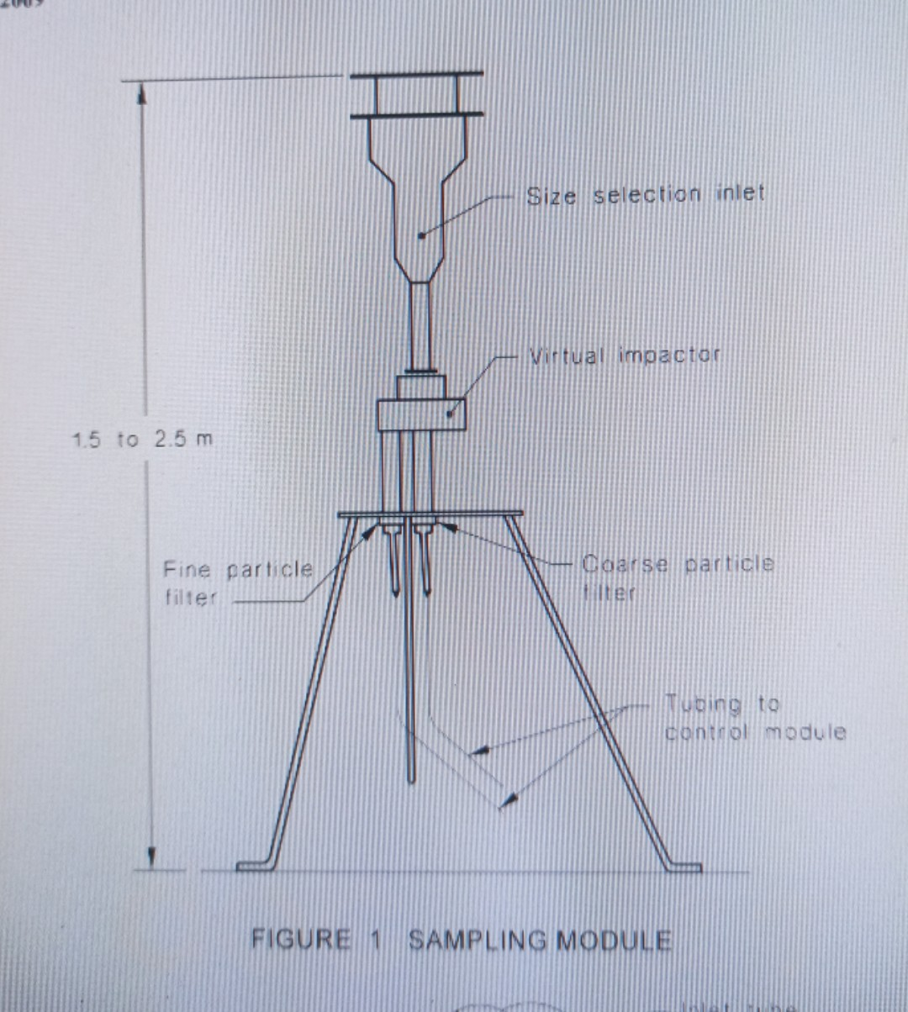
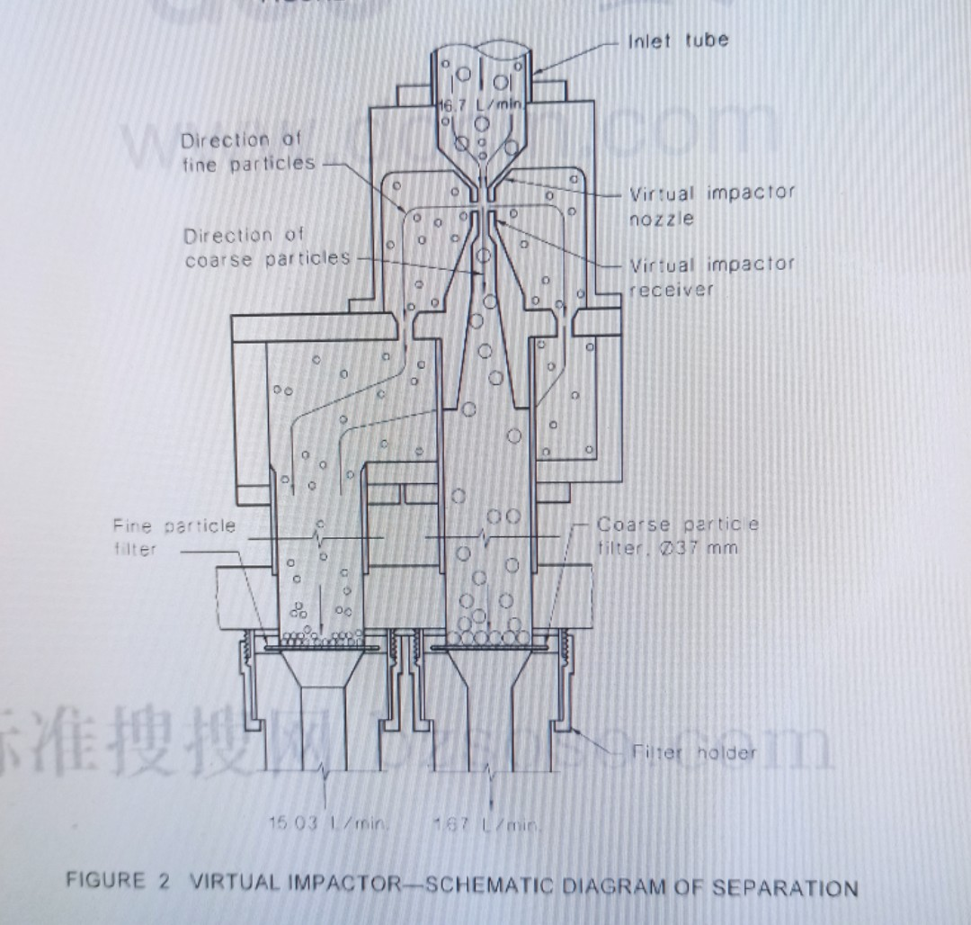
6 CALIBRATION

6.1 General requirements Verification checks of the dichotomous sampler's ambient temperature and pressure measuring devices (if equipped) shall be conducted on an annual basis against transfer standard instruments (see Clause 5.7 and 5.9). A full calibration of the temperature measuring device shall be conducted if the verification check indicates a difference equal to or greater than 2°C. A full calibration of the pressure measuring device shall be conducted if the verification check indicates a difference equal to or greater than 1.3 kPa. Calibration of the sampler's flow control and measurement device is required (see Clause 5.5).
6.2 Flow rate calibration The procedure shall be as follows:
(a) Ensure that clean filters have been installed
(b) Perorm a system leak check . A leakage rate less than 1% of the sample design low rate , at the maximum operating pressure drop, is accptable
(c) Connect the flow meter to the sampler inlet (an adaptor may be required) to accurately measure the dichotomous sampler's total flow rate through the fine and coarse fraction filters. For a bubble meter, time the period for the bubble to sweep the calibrated volume, and calculate the flow rate. The volume of a manually timed bubble meter shall be such that the measured time period is a minimum of 15 seconds.
(d) Verify that the total flow rate as indicated by the flow meter is within 16.7 L/min +6%.
(e) The coarse fraction flow stream is calibrated by
(i) disconnecting the fine particle flow line below the fine particle filter holder, and plugging the outlet of the fine particle filter holder so that back flow cannot occur and all air flow passes through the coarse particle flow meter; and
(ii) operating the sampler solenoid valve which isolates the fine particle flow stream. (f) Verify that the coarse flow rate as indicated by the flow meter is within 1.67 L/min +6%. The fine fraction flow stream is calibrated by
- disconnecting the coarse particle flow line below the coarse particle filter holder, and plugging the outlet of the coarse particle filter holder so that back flow cannot occur and all air llow passes through the fine particle flow meter; and
(ii) operating the sampler solenoi valve which isolates the coarse particle flow stream
(h) Verify that the fine particle flow rate as indicated by the flow meter is within
15 L/min 16%. Record the ambient temperature and barometric pressure using the thermometer 15,7) and barometer (5.9).

(1) Temperature and pressure corrections to the sampler indicated total, coarse fraction and fine fraction flow rates may be required for certain flow measurement devices (mass flow controllers), to enable comparison with the reference flow meter measurement and the design flow rates. When temperature and pressure corrections are necessary, the temperature and pressure at the time on calibration shall be used
UN JOV, 7.1.VU

(k) Calibration of the total, coarse fraction and fine fraction flow rates shall be carried out according to the manufacturer's recommendations but at least every 6 months where mass flow controllers are used.
Other flow rate measurement devices may require more frequent calibration. A full three point flow rate calibration shall be carried out annually for each flow stream. Single point total flow rate verification checks shall be carried out monthly. If the verification check indicates a total flow rate variation greater than 16.7 L/min 6%, a full three point calibration is required for each flow stream. If the verification check indicates a total flow rate variation greater than 16.7 L/min +10%, all samples obtained since the previous verification check shall be rejected

NOTE: Dichotomous samplers use various types of flow control and flow measurement devices. The specific procedure used for flow rate calibration or verification will vary depending on the type of flow controller and flow indicator used. Calibration in terms of actual volumetric flow rate is generally recommended, but other measures of flow rate eg, mass flow controller (MFC) may be used providing the requirements in Clause 5.5 are met. Consult the manufacturer's operational manual for specific guidance on calibration.

7. PROCEDURE

7.1 Filter preparation

A laboratory environment with a controlled atmosphere is required for conditioning and weighing filters for the entire conditioning period with a mean temperature between 20°C and 23°C, controlled within limits of +2°C from the mean, and a mean relative humidity (RH) between 30% and 40% controlled within limits of +5% RH from the mean. The temperature and humidity of the controlled environment shall be recorded for each filter conditioning and weighing session at minimum intervals of 15 minutes. The mean relative humidities for pre- and post-sampling filter conditioning and weighing sessions shall be within +5% RH. Post-sampling conditioning shall be completed within 20 days of the completion of sampling (30 days if samples are maintained at <4°C).

Laboratory and field blank filters shall be run to determine both the reproducibility of filter equilibration conditions and errors introduced due to filter handling. Exposed samplc filters typical of the site location and particle loading of the proposed measurement location can be used as an additional quality control procedure (variations in relative humidity are more likely to affect the mass of collected particulate matter than the filter media. hence, the use of exposed filters). Filters shall only be handled using clean smooth non-serrated forceps.

The procedure for filter preparation shall be as follows:

(a) Check all filters for pinholes, particles and imperfections using the light-table. Reject any filters that are found to be laulis
(b) Place each filter in a separate Petri dish with resealable lid marked with a unique identification number on the lid and the base. Alternatively, manufacturer prenumbered filters may be used.
NOTE: Do not mark the filter,
(c)Remove the lid from its base and equilibrate the filter in the conditioning environment for at least 24 hours.
(d) Following equilibration, neutralize the static charge on the filter, support ring side up (if applicable), using a static eliminator, then weigh each filter and record the initial mass with the filter identification number Weigh each filter until three consecutive weights are measured within 15 pg.
(e) Return the filter to the Petri dish

7.2 Instrument siting
The instrument shall be sited in accordance with the requirements of AS/NZS 3580.1.1.

7.3 Sampling
The following sampling procedure shall be followed: dichotomous sampler according to the manufacturer's operational manual.

(a) Set up the dichotomous sampler according to the manufacturer’s operational manual
(b) Place the tared coarse fraction and fine fraction filters in the sampler, or filter cassettes in the case of a sequential sampler, following the manufacturer's instructions.
(c) Turn on the sampler and allow to stabilize.
(d) Inspect the sampler to ensure that there are no leaks in the sampling train in accordance with the manufacturer's instructions.
(e) Record the initial total flow rate corrected to actual ambient temperature and barometric pressure. If the flow rate is outside the acceptable range for the size selective inlet (16.7 L/min +6%), then a flow adjustment or calibration is necessary. Non-sequential samplers shall be operated until a stable reading is obtained before recording the initial flow rate and then switched off. Stop the sampler.

(f) Set the sampler to start and stop at the appropriate times.
(g) Sample for a predetermined time and period. th
(h) Record the final total flow rate corrected to actual ambient temperature and barometric pressure. If the final flow rate differs from the initial flow rate by more than 6%, a warning flag indicator shall be included with the reported result. If the final flow rate differs from the initial flow rate by more than 10%, the sample obtained shall be rejected. Non squential samplers should be operated until a stable reading is obtained with the exposed filter in place prior to recording the final flow rate and then switched off.
(i) Carefully remove the filters from the sampler, or filter cassettes in the case of a sequential sampler, following the manufacturer's instructions using clean smooth non-serrated forceps. The sample filters shall be removed within 14 days of the sample period.
(j) Replace each filter back into its lablled petri dish
(k) Record all relevant details in the instrument log including the following:
(i) Date and time sample was taken
(ii) Date sample was removed (and new filter installed , if appropriate)
(iii ) Sample Sample and field blank filters identification numbers
(iv) Site location or site identification number.
(v) Sampler model and serial number.
(vi) Elapsed sampling time.
(vii) Indicated instrument time (ensure time is correct to within 15 minutes of actual time).
(viii) Verification that sampler timer was in the correct sample sequence.
(ix) Operator's identification
(x) Any relevant comments including meteorological conditions local construction activity, fires and dust storms that may have affected the final mass loading

(l) Transport the exposed fine fraction and coarse fraction sample filters to the filter weighing and conditioning environment as soon as practical for equilibration and subsequent weighing. The period between sampling and final weighing shall not exceed 20 days (or 30 days at <4°C).

NOTE: The period between sampling and final weighing should be as soon as possible. (m) Equilibrate the sample filters in the conditioning environment for a minimum of 24 hours, at the conditions specified in Clause 7.1.
(n) After equilibration re-weigh sample, laboratory blank and field blank filters and
record weights associated with the filter identification numbers, as described in Clause 7.1.
(0) Replace the filters in their labelled Petri dishes for safe storage.

NOTES:
1 The changing of filters during windy or rainy conditions should be avoided, in order to
minimize sample loss. If changes need to be made during adverse weather conditions the filter holder should be removed to a protected location.
2 After sampling, the Petri dishes containing the sample filters should be kept in a horizontal position and carried with the utmost care in order to ensure that particles are not lost or dislodged from the filters.
3.Sample filters should not be exposed to extremes of temperature which could result in loss of semi-volatile compounds collected on the filters. Where possible sample filter collection should occur in the morning, with samples protected from direct sunlight and transported in an air-conditioned vehicle. If filter temperatures could exceed 25 C during transport, then appropriate measures should be taken to ensure that this does not occur.

8 MAINTENANCE
The dichotomous sampler and size selective inlet should be maintained in accordance with the maintenance procedures specified in the instrument manufacturer's operational manual. Minimum maintenance periods are, however, specified in Appendix B.

9 CALCULATION
9.1 General
The mass concentrations shall be calculated over the sampling period and corrected to standard temperature and pressure conditions 0°C and 101.3 kPa. 9.2 Volume of air sampled Calculate the total, coarse fraction and fine fraction volumes of air sampled using the following equation:

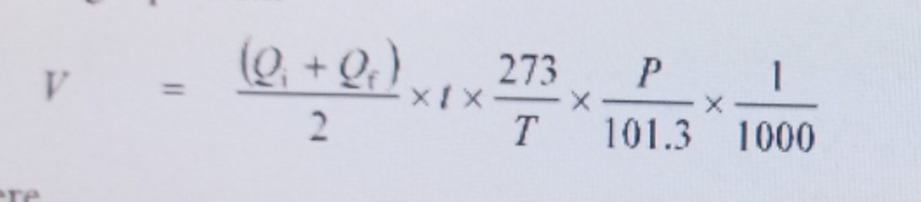
V = volume of air sampled, in cubic metres, corrected to 0ºC and 101.3 kPa
Q_{i} = initial flow rate, in litries per minute
Q_{f} = final flow rate, in litries per minute
t = sampling time, in minutes
T = estimated mean ambient temperature over the sampling period, in Kelvin
P = estimated mean ambient barometric pressure over the sampling period, in kilopascal

Alternatively the fine fraction volume may be calculated by subtracting the coarse fraction volume from the total volume.
9.3 Calculate concentration
Calculate the concentration of suspended particles in the air sample collected on each filter and determine the PM25, coarse PM and PM, concentrations from the following equations:
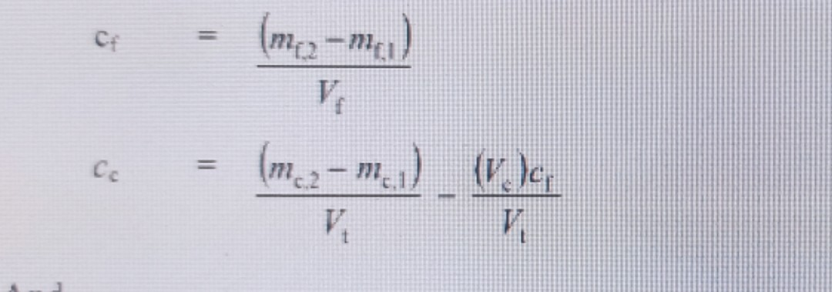
Và
PM₁₀ = c_{f} + c_{c}
PM_{2.5} = c_{f}
Coarse PM = c_{c}
Tại đó
C_{f} = concentration of fine particles in the air sample, in micrograms per cubic metre
m_{f.1} = initial mass of the fine fraction filter, in micrograms
m_{f.2} = final mass of the fine fraction filter, in micrograms
V_{f} = fine fraction sample volume, in cubic metres
V_{c} = coarse fraction sample volume, in cubic metres
V_{t} = total sample volume, in cubic metres
C_{c} = concentration of coarse particles in the air sample, in micrograms per cubic metre
m_{c.1} = initial mass of the coarse fraction filter, in micrograms
m_{c.2} = final mass of the coarse fraction filter, in micrograms.

10 MEASUREMENT UNCERTAINTY
The method measurement uncertainty is typically estimated at ± 5 µg/m³ U₉₅ over the entire measurement range for the PM_{2.5} and PM₁₀ size fractions, however the measurement uncertainty should be determined based on individual laboratory sampling and weighing procedures.
The measurement uncertainty estimate of ± 5 µg/m³ U₉₅ applies only to the volume, time and mass measurement components of the PM_{2.5} and PM₁₀ measurements. It does not include the measurement uncertainty associated with how representative the sample is of the particular atmosphere sampled.

11 QUALITY ASSURANCE
Filter identification shall be checked with the chain of custody record. The filter shall be inspected for evidence of leaks, damage or misalignment. The dichotomous sampler shall be within its recommended calibration period. For 24-hour sampling the run period shall be 24 ±1 h
Laboratory and field blank filters shall be taken to determine the reproducibility of the filter equilibration conditions.

NOTE: Exposed sample filters may also be used as an additional quality control procedure. If taken they should be typical of the site location and particle loading of the proposed measurement location (variations in relative humidity are more likely to affect the mass of collected particulate

matter than the filter media, hence, the use of exposed filters). Laboratory blanks shall be taken at a minimum rate of 1:10 sample filters. Field blanks shall be taken at a minimum rate of 1:20 sample filters. They are used to ensure that filter handling. transport and conditioning procedures are not biasing results. The field blank procedure involves transporting, installing and removal of a tared filter in the sampler without sample air being drawn through the filter. A variation in PM_{2.5} or coarse fraction mass greater than ±15 µg between pre- and post-weighings of a laboratory blank filter indicates a problem which requires remedial action. A variation in PM_{2.5} or coarse fraction mass greater than ±30 µg between pre- and post-weighings of a field blank filter indicates a problem that requires remedial action.

12 REPORT
The following information shall be reported:
The following information shall be reported:
(a) Reference to this Standard, ie. AS/NZS 3580.9.7.
(b) Type of size-selective inlet used (manufacturer and model number).
(c) Type of filter used (including pore size).
(d) Reporting organization.
(e) The concentration of PM_{2.5}. coarse PM and PM₁₀ , in air, in micrograms per cubic metre at reference conditions 0°C and 101.3 kPa, together with the related time averaging period.
(f) Location of the sampler-all relevant details, including a coordinate reference to within 100 m, height above ground level, classification of area (peak station, neighbourhood station or background station).
(g) Any non-conformance with AS/NZS 3580.1.1.
(h) The dates, times, and period of sampling. NOTE: It should be stated whether time is expressed as local or standard time or daylight saving time
(i)Any other relevant data, e.g. meteorological conditions, proximity to bush fires, farm ploughing activities, traffic on unsealed roads.
NOTE: The reporting of data depends somewhat on its future use. Additional relevant information which could be reported includes the following:
(a) Mean values (quarterly or annual).
(b) Maximum values (eg monthly).
(j) The uncertainty associated with the measurement along with the confidence interval and coverage factor according to ISO GUM.

APPENDIX
ASSESSMENT OF THE PERFORMANCE OF DICHOTOMOUS SAMPLERS
(Normative)

A1 SCOPE
This Appendix sets out a procedure for assessing the performance of dichotomous samplers and specifies the acceptance criteria for determining equivalence of the samplers to US EPA reference samplers. The method is the field test procedure in EN 12341 with the following modifications.

A2 SITING OF SAMPLERS
A2.1 General

For the sample collection procedure. candidate dichotomous samplers and US EPA reference dichotomous samplers shall be sited in accordance with AS/NZS 3580.1.1. The exhausts from the samplers shall be ducted so that the filtered air from any sampler does not enter adjacent samplers.
The procedure in EN 12341 shall be adopted with the variations set out.
A2.2 Reference samplers
Dichotomous sampler designated as a US EPA reference dichotomous sampler.
A2.3 Test sites
Test sites shall comply with the siting criteria in AS/NZS 580.1.1.
A2.4 Site characteristic
Site characteristic not required
A2.5 Operational procedures The handling, conditioning and weighing procedures shall follow those outlined in this Standard The measurements shall cover a commonls countered range of environmental conditions
Conditions shall conei a range of temperature, wind speed and relative humidity conditions
Number of samples shall be as follow for each range of PM_{2.5} concentration:
(a) 5 samples: < 10µg/cm³
(b) 30 samples: ≥10 và <25µg/cm³
(c) 5 samples: ≥25 µg/cm³
The techical competence of testing labotary shall be according to the criteria in AS ISO/IEC 17025

APPENDIX B
MAINTENANCE AND CLEANING OF EQUIPMENT
The following maintenance program shall be followed for dichotomous samplers:
Component for maintenance | Timing of maintenance
Condition of size selective (e.g V-seals and rubber o-rings) | Check every filter change operation
Cleaning of size selective inlet/virtual impactor | Inspect monthly and clean as required
Pump | Annual or when operation is suspect
Inlet tube/sampler cleaning | Two-monthly
Site compliance with AS/NZS 3580.1.1 | Annual audit of sitting criteria
Safety inspection | Check every filter change operation
Pulsation dampener(if equipped) | Inspect two-month for leaks

Amongst other aspects, the safety inspection should ensure that electrical leads, if used, are suspended above ground level, and are connected by residual current device to mains power, in accordance with the requirements of AS/NZS 3760.
The frequency of cleaning depends on typical particle concentrations at the measurement site, and the frequency of sampling.
WINS impactors shall be cleaned thoroughly after every 5 sample days. A new borosilicate glass fibre filter shall be inserted and 1.0 +0.1 ml of impactor oil shall be added prior to reassembly
Sharp cut or very sharp cut cyclones shall be cleaned thoroughly alter even 30 sample days
Refer to the manufacturer's instruction manual for cleaning trequency of other size elective intets

Keeping Standards up-to-date
Standards are living documents which reflect progress in science, technology and systems. To maintain their currency, all Standards are periodically reviewed, and new editions are published. Between editions, amendments may be issued. Standards may also be withdrawn. It is important that readers assure themselves they are using a current Standard, which should include any amendments which may have been published since the Standard was purchased.
Detailed information about joint Australian/New Zealand Standards can be found by visiting the Standards Web Shop at www standards com.au or Standards New Zealand web site at www standards.co nz and looking up the relevant Standard in the on-line catalogue
Alternatively, both organizations publish an annual printed Catalogue with full details of all current Standards. For more frequent listings or notification of revisions, amendments and withdrawals. Standards Australia and Standards New Zealand offer a number of update options For information about these services, users should contact their respective national Standards organization.
We also welcome suggestions for the improvement in our Standards, and especially encourage readers to notify us immediately of any apparent inaccuracies or anbiguities. Please address your comments to the Chief Executive of either Standards Australia International or Standards New Zealand at the address shown on the back cover

